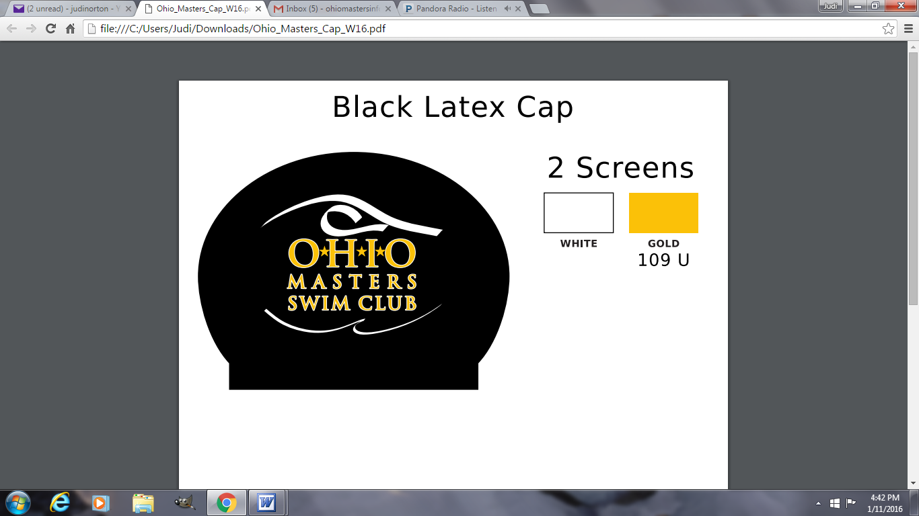

The Lifetime Achievement Service Award recognizes the O\*H\*I\*O Masters Swim Club member whose service has contributed to the growth, improvement, and/or success of the Club.

Please describe the candidate’s contributions and why you feel they should be honored.

1. In what role(s) has the candidate contributed
2. How have his/her contributions benefitted the Club and its members?
3. Personal anecdotes or endorsements from fellow members
4. Additional Comments

Nomination due by March 31. Submit nominations to: infoohiomasters@gmail.com

Award presented at Annual meeting held in June.

The Lifetime Achievement Performance Award recognizes the O\*H\*I\*O Masters Swim Club member whose performance in the water has demonstrated consistent and outstanding results in competition in USMS. Criteria follows:

* Have excelled in a minimum of three age groups
* Are regular participants in competition
* Demonstrate good sportsmanship
* World records and rankings
* National records and rankings
* World and National Championship participation

Please provide the following information

1. List Achievements and Highlights (include age group, event, time, date & location)
2. List Records at World and National level (include age group, event, time, date & location)
3. List World and National Championship participation (include age group, event, time, date & location)

Nomination due by March 31. Submit nominations to: infoohiomasters@gmail.com

Award presented at Annual meeting held in June.